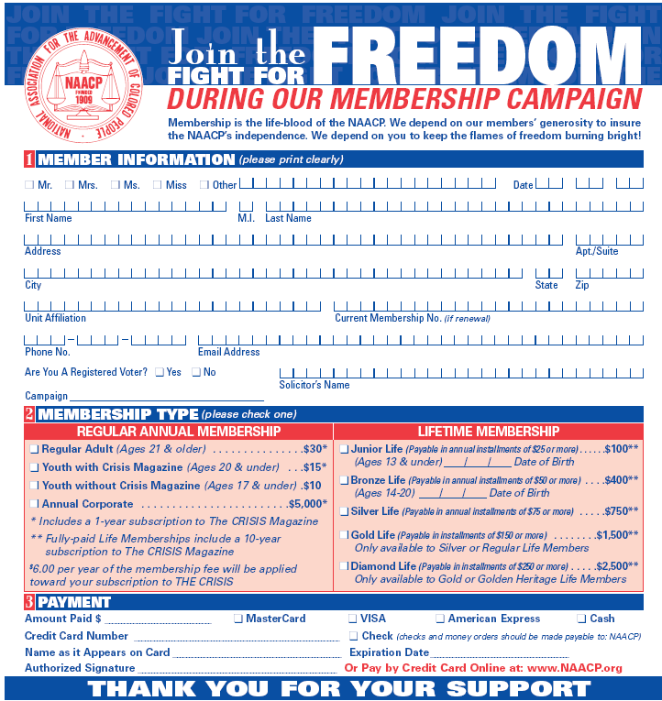
Please mail your completed application to:
WACO NAACP
PO Box 20511
WACO, TX 76702
Email or call with questions (waconaacp@gmail.com/254-733-5261).
Make check or money order payable to WACONAACP.
You may also pay by Paypal using the email: waconaacp@gmail.com.

