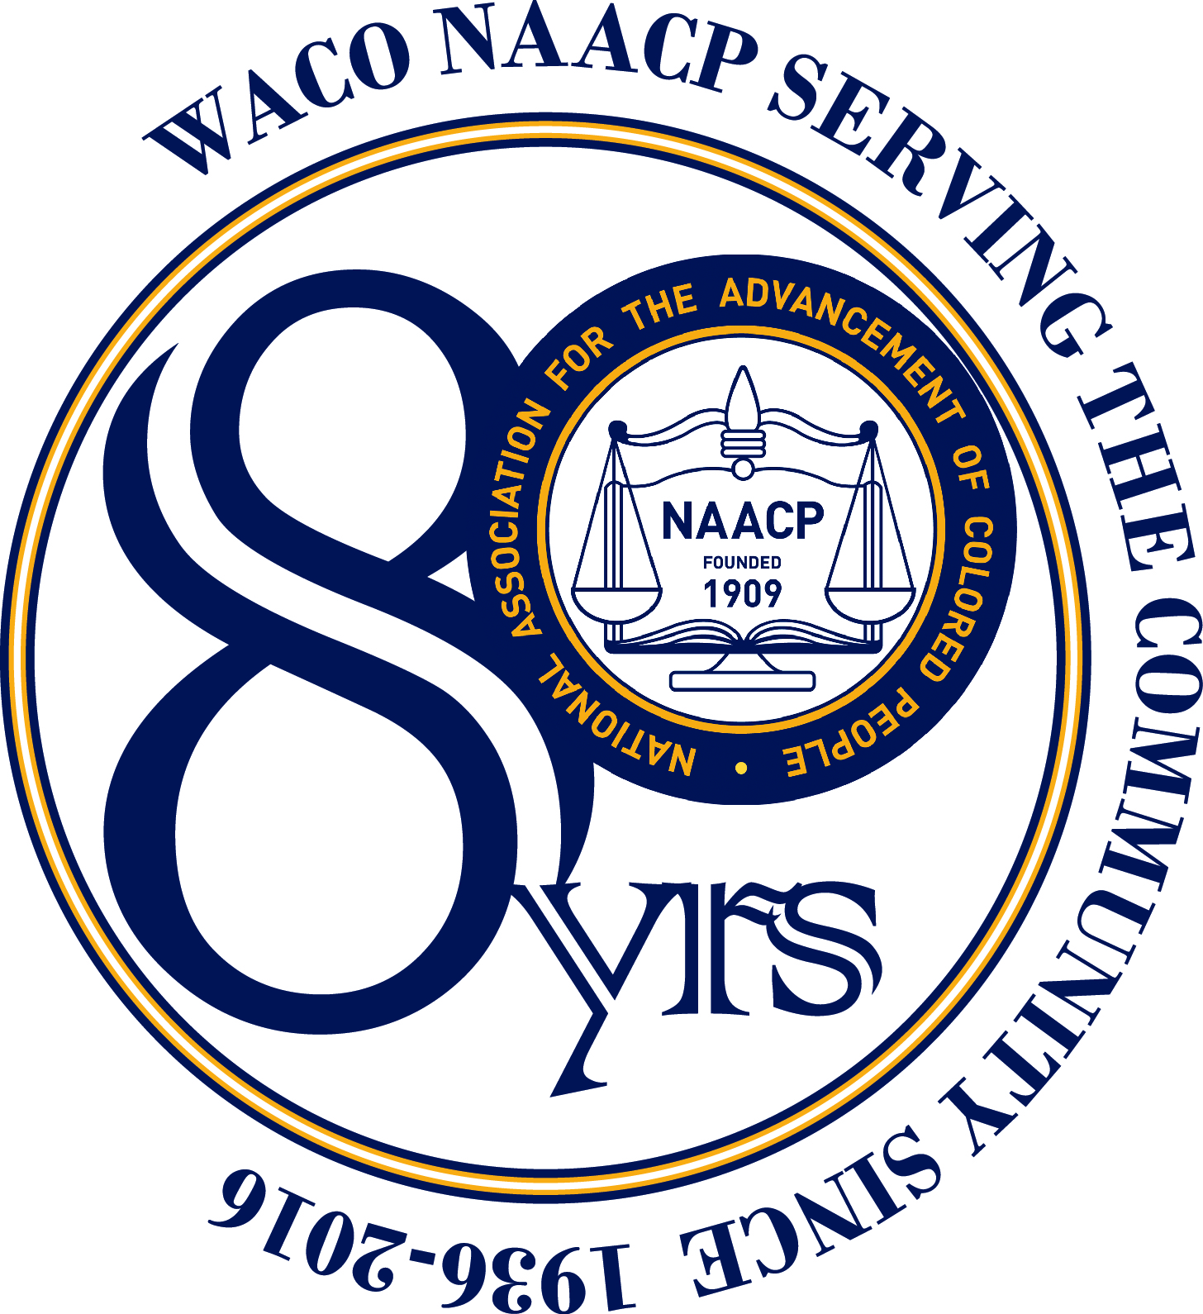

Waco NAACP 2015 Annual Report
December 14, 2015
Presented by
Dr. Peaches Henry, President

Overview
During 2015, the Waco NAACP has worked diligently to implement the objectives of the National Association for the Advancement of Colored People in the Waco McLennan County community. In January, the chapter marked Martin Luther King, Jr. Day by participating in Zeta Phi Beta and Phi Beta Sigma’s annual march and wreath-laying ceremony. On Founders Day in February, the chapter honored our past presidents at a special reception. At the annual banquet, the chapter honored plaintiffs in two 1970s voting rights cases that secured single-member voting districts for citizens in Waco and East Texas. In March, the chapter held a commemorative march to mark the fiftieth anniversary of the 1965 Selma Marches. With over 100 people attending, we honored those who sacrificed on our behalf and rededicated ourselves to the ongoing fight for our rights. In May, the chapter inaugurated the Rev. Robert L. Gilbert Scholarship and the Dr. Mae Jackson Scholarship, awarding three scholarships to local students at the Scholarship Banquet. In July, the Waco NAACP president and vice-president represented the chapter at the NAACP National Convention in Philadelphia, Pennsylvania where the first African-American president Barack Obama and the first African-American female United States Attorney General Loretta Lynch spoke. On August 8-9, the chapter partnered with Project VIER to host the Ambassadors for Democracy Voting Rights Summit featuring the Lawyers’ Committee from Washington, DC to commemorate the fiftieth anniversary of the 1965 Voting Rights Act. Throughout the year, the chapter partnered with other organizations to protect the voting rights of the citizens of McLennan County. To be sure, as it heads into its eightieth year of service to McLennan County, the Waco NAACP remains committed to the ongoing struggle for civil and political liberty.

Membership
Starting in January, the Membership Committee took steps to increase the chapter’s membership. At the Martin Luther King, Jr. March and Wreath-laying Ceremony and the Martin Luther King, Jr. Candlelight Vigil, the committee distributed 250 bookmarks with membership applications printed on the reverse side and increased its membership by fifty percent during the first quarter. In May at the Know Your Right Forum and in June at the Juneteenth Family Fun Day, the committee distributed membership information. The membership of the Waco NAACP is nearing 100 members including the addition of one sustaining life member.
Economic Empowerment
The Economic Empowerment Committee hosted two Financial Freedom Seminars presented by the Texas State Assistant Treasurer Brian Rowland. The Committee monitored the activities of the Prosper Waco Initiative. The Committee attended the public meeting of Prosper Waco in the African-American community. When after the meeting Prosper Waco published a document that did not represent the community’s input, the committee chairwoman called Prosper Waco on it and got the director to correct the publication. The chapter supported the Citizens for Responsible Lending Coalition in its efforts to get the Waco City Council to pass a Payday Lending Ordinance.

Education
The Education Committee created two scholarships: The Robert L. Gilbert Scholarship, named for the first African American to attend Baylor University, and the Dr. Mae Jackson Scholarship, named for the first African-American woman mayor of Waco. In February, the Committee invited Dr. Bonnie Lesley, founder of “Texas Kids Can’t Wait,” the statewide advocacy organization for equitable funding of public schools, to speak on the legislative issues affecting our children’s education. In May, the Committee hosted the Scholarship Banquet during which the Robert L. Gilbert Scholarship and the Dr. Mae Jackson Scholarship were awarded. The Education Committee participated in the Road to Damascus Back-to-School Bash during which members registered voters, educated people on the voting process, and taught children and their parents how to use a voting machine. The Committee registered 20 voters and taught nearly 100 people to use the voting machine. At the September meeting, the Committee hosted a presentation by Dr. Bonny Cain, Waco ISD Superintendent, on the tax ratification election that occurred in November.

Health
In January, the Health Committee partnered with EnrollAmerica to host a Health Insurance Information and Enrollment Session at Carver Park Baptist Church. The Committee hosted two additional enrollment sessions. As part of the Smoke Free Waco Coalition, the Health Committee lobbied the Waco City Council to support a comprehensive smoke free ordinance. The Waco NAACP delivered 125 letters from citizens supporting the ordinance to City Councilman Gilbert Austin. The ordinance passed on July 21, 2015. In October, the Health Committee participated in World Hunger Day by distributing healthy-eating fliers at the Farmers Market. The Committee noted Breast Cancer Awareness Month by having a representative from Susan G. Komen speak at the October meeting. At the same meeting, the Health Committee kicked off the Healthcare Marketplace Enrollment Period; the regional director of EnrollAmerica trained the chapter on phone banking. The chapter held a Healthcare Phone Bank on October 29. The chapter distributed healthy-eating fliers and fliers announcing the Healthcare Information and Enrollment Event at a Waco High football game on November 6. On November 14, the chapter held a Healthcare Information and Enrollment Event. In December, the chapter provided water to the Marlin schools when the city's water supply was shut off.

Legal Redress
The Legal Redress Committee met with the Waco Police chief to handle complaints the chapter received and to develop a protocol for handling situations involving police and citizens such as those in Ferguson and North Charleston. The Committee hosted a "Know Your Rights Forum" with a panel of the Waco Police Chief, the Waco ISD Police Chief, the Director of the Emergency Services Education Center (which includes the Law Enforcement Academy), several defense attorneys, and civil justice activists. Throughout the year, the Committee handled and resolved numerous cases involving racial profiling, housing discrimination, job discrimination, and other types of complaints.

Political Action
The chapter participated in the Martin Luther King, Jr. Day March and Wreath Laying Ceremony. The chapter partnered with Zeta Phi Beta Sorority, Inc. Delta Upsilon Zeta Chapter and Phi Beta Sigma Fraternity, Inc., Gamma Omicron Sigma Chapter to distribute and discuss the NAACP's "Police Interaction Guide: The 411 on the 5-O to local youth.” The chapter arranged for the McLennan County Elections Office to attend a meeting to deputize the membership to register voters. In March, the chapter joined several organizations to fight efforts by the McLennan County Elections Office to draw redistricting lines that would have negatively affected the voting power of several minority precincts. Candidates for the Waco City Council and the Waco ISD School Board spoke at the April monthly meeting. The chapter educated voters on voting machines and registered voters at the Juneteenth Family Fun Day event which hosted about 5000 people. To commemorate the fiftieth anniversary of the 1965 Voting Rights Act, the chapter hosted a 2-day Ambassadors for Democracy Summit. On August 8, a representative from the Lawyers' Committee for Civil Rights conducted a seminar on monitoring voting changes and protecting the vote for fifty community activists from McLennan and Bell counties. On August 9, the chapter held a Picnic and Politics in the Park event to register and educate voters. The chapter participated in National Voter Registration Day (September 22) at McLennan Community College registering 85 voters. The chapter registered voters at the Heart of Texas Fair on October 9. In November, the chapter again joined several organizations this time to fight efforts by the McLennan County Elections Office to close polling places in two minority areas, the Paul Quinn Multi-Purpose Building location and the Cesar Chavez Middle School.

Coalition Building
The Waco NAACP president created Project VIER (voter id, education, and registration), a coalition of organizations in the area committed to protecting the vote and increasing civic engagement. During the Ambassadors for Democracy Summit, the Project VIER coalition added the InterWaco-LGBQT Community Group. The chapter worked with the Texas Democratic Women, the McLennan County Democratic Party, and McLennan County Commissioner Lester Gibson to prevent repeated attempts by the McLennan County Elections Office to close precincts and polling places in the county. The Waco NAACP partnered with the Community Race Relations Coalition, Waco Community Development, and the Center for Elimination of Disproportionality and Disparities to host a viewing of the film series, Race: The Power of an Illusion and discussion afterwards.

